User Guide 4 Advertising an Application
Purpose of this User Guide
The purpose of this User Guide is to assist Responsible Authorities with advertising an application in SPEAR.
Who should read this?
Primary audience: Responsible Authorities, referral authorities and Applicant Contacts
For information: Applicants and the public
Introduction
Responsible Authorities are prompted to consider advertising requirements for SPEAR planning permit applications once they have accepted the application. SPEAR enables advertised planning applications to be viewed online using the SPEAR Public Search function. This provides a more convenient option for the public to view an advertised application and may reduce the number of inquiries to the Responsible Authority.
SPEAR also provides an online objection facility whereby an objection can be lodged to the Responsible Authority using SPEAR.
4.1 Advertising a planning application in SPEAR
On accepting an application for a planning permit or a joint planning permit and certification, the Responsible Authority is prompted to decide whether an application is required to be advertised.

Advertising Options
From the Details tab, the Responsible Authority user must first select the mandatory action ‘Add Advertising Instructions’, which will open the Determine Advertising Requirements screen.
One of the following options must then be selected (refer to screenshot below):
- ‘Application does not require advertising’
- ‘Add advertising requirements in SPEAR’
- ‘Advertised outside of SPEAR’
If advertising is required, either through SPEAR or outside SPEAR, the Responsible Authority is required to indicate the ‘Advertising Period Complete Date’. This will automatically be displayed as 14 days from the current date; however it can be altered using the date picker.
SPEAR will use the date supplied to drive a new SPEAR status ‘Permit Decision Pending (Currently Advertised)’ which will be displayed if all Section 55 referral responses are received prior to the completion of the advertising period. In these cases, when the advertising period ends, the application status will then move to ‘Permit Decision Pending’ with a relevant email notification to the Responsible Authority.
Where the Responsible Authority has indicated that they will be adding the advertising requirements in SPEAR, the following information is also to be supplied:
- Indicate whether advertising is to be performed by the applicant, the Responsible Authority or both.
- Indicate if a signed declaration is required to be provided by the applicant. If ‘Yes’ is selected, a mandatory action will appear for the applicant to provide a ‘Statutory Declaration for Advertising’.
Alternatively, should the Responsible Authority be provided with a signed declaration outside of SPEAR, they may use the optional action ‘Add Statutory Declaration for Advertising’, which will remove the mandatory action previously placed on the applicant.
- Select the application documents that will be available to the public via SPEAR for the application. Selected documents will be visible from the Application Overview screen, following a public search.
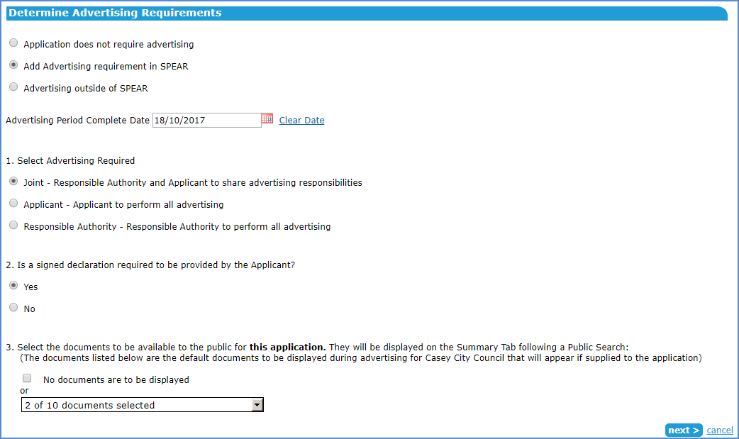

After clicking ‘next’, the Responsible Authority user is required to supply the advertising instructions (as a PDF or free text). Once the document is authenticated, it will be saved in SPEAR and an email notification sent to the Applicant Contact notifying them of the advertising requirements.
The Responsible Authority can also send an invoice to the Applicant Contact for any fees associated with the advertising process by selecting ‘Add invoice – Advertising’ from the ‘Other Actions’ drop-down list.
4.2 Sending a notification of advertising to referral authorities
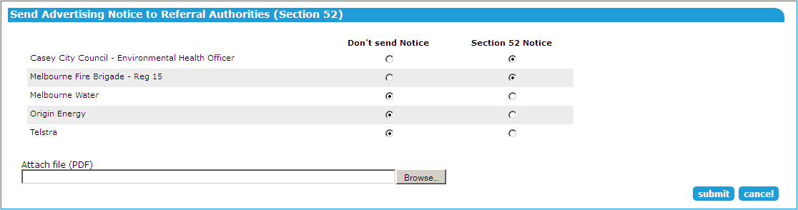
The Responsible Authority can send notification of an application to one or more referral authorities (Section 52). This can be done by selecting the optional action ‘Send Advertising Notice to Referral Authorities’ after authenticating the advertising instructions.

The Responsible Authority selects which referral authorities are to receive notification of the advertised application. Once authenticated, the selected referral authorities are then notified that an application is being advertised and they have the option to forward a submission.
Need more information?
Further information on this topic can be found by:
- Visiting the SPEAR website www.spear.land.vic.gov.au/SPEAR
- Contacting the SPEAR Service Desk on 9194 06123 or email spear.info@delwp.vic.gov.au
- Referring to User Guide 13 - What can the public do in SPEAR?

